To use this template, make a copy by selecting FILE / MAKE A COPY to make your own Google Docs file, or FILE / DOWNLOAD to create a word doc if you’d prefer to work offline.

## **Project “Dream World” 1.5-Page GDD**

*A land in the world of dreams is in danger of extinction and needs a hero to save it.*

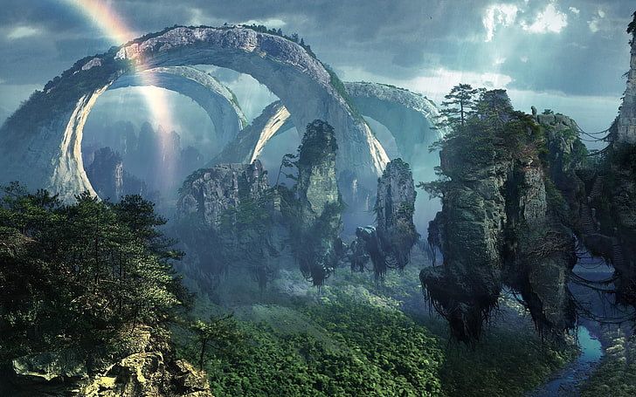

**Genre:** 3rd Person Action RPG, Single Player, Fixed Camera  
**Target Audience:** 18+ (MA for Mature) fans of old school RPGs

**Controls:** Mouse and Keyboard

**Thematic Setting:** Fantasy / Dungeons & Dragons

**Tech Stack:** Unity 2021.3, Audacity, Asset store for 3D and UI

**Platform(s):** Steam, Android

**MVP Game Moment:** 2 minutes of simple linear level flow with basic combat against 3 or 4 enemies.

**Game Summary:** A middle-aged man falls asleep and starts to dream of a world that seems to be having issues. At least it feels like a dream, that is until the things, like emotions and pain, seem to be too real at times. As he adventures along in the game, he discovers that this “dream” world has been falling apart, and that he was brought to this world to help save it and bring back peace to the land. Will our protagonist be able to do all the things that are necessary to help save this world, and if he does what does that mean for him?

**Core Player Experience:** Confusion / Desire / Heroic

**Central Story Theme:** A hero from another world to save the one that is failing.

**Design Pillar:** Having the hero go around the world and help to repair the failing areas.

**Remarkability:** An everyday person saves a world - Isekai

**Anticipated Prototype date:** End of 2024

**Feature Development Priorities:**

* Real-time combat with tons of different enemies
* All the required RPG abilities and stats (upgradeable)
* Level building and game progression
* Branching dialogue system
* Inventory, loo, usable items

**Reference Games:** Diablo, Torchlight 2, Ember